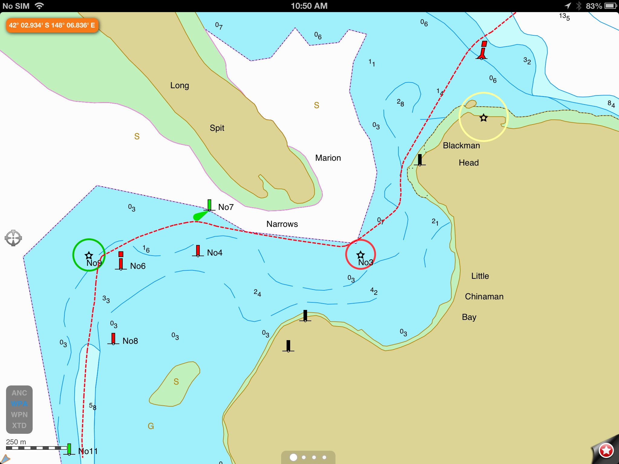

**Fl 3s**

**Fl 4s**

**3.4**

**Fl 4s**

**Fl 2s**

**Fl 2s**

**SANDBAR LOCATED CLOSE TO CHANNEL BETWEEN No.4 and No.6 BEACONS**

**6.1**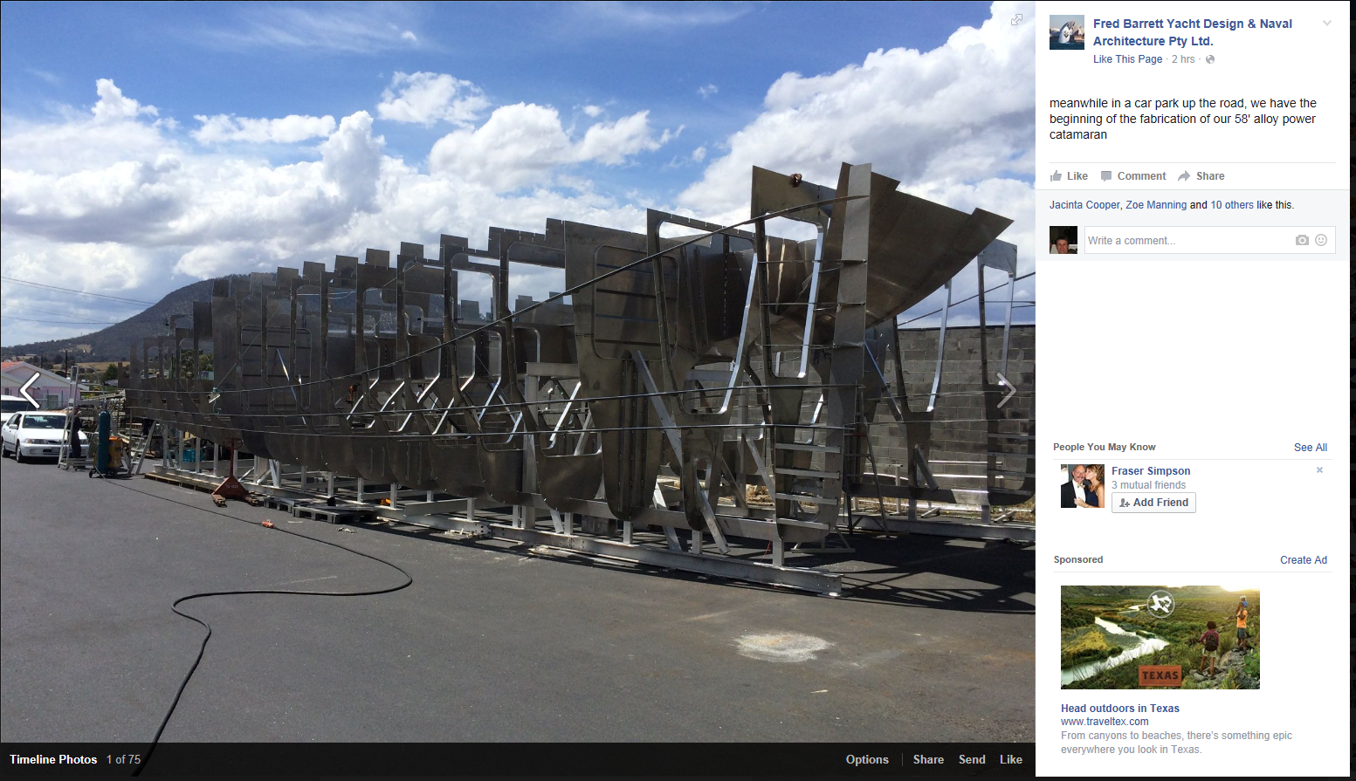****

Unlit [jackpage187j@gmail.com](mailto:jackpage187j@gmail.com)>

**4.7**

**2.2**

**9.8**

**6.2**

**NOTE: VESSEL TRACK IS EAST OF THE ENTRANCE LEADS**

**THIS CHARTLET IS NOT TO BE USED FOR NAVIGATION**

**PRINTING OF THIS CHART MAY ALTER SIZE AND SCALE OF THE BACKGROUND CHART IMAGERY**

**MARION NARROWS CHARTLET 19 DECEMBER 2024**

**THE DEPTHS SHOWN WITHIN THE BLACK BOXES AND THE COURSE (SHOWN AS A DOTTED RED LINE) DO NOT FORM PART OF A NAUTICAL CHART.**

**DEPTHS SHOWN ARE IN METRES AT CHART DATUM REDUCED USING HOBART TIDE TABLES.**

**THIS INFORMATION HAS BEEN OVERLAID ONTO THE CHART BY MARINE AND SAFETY TASMANIA TO PROVIDE GUIDANCE TO MARINERS ABOUT THE SHIFTING CHANNEL AT MARION NARROWS.**

**THE DATA PROVIDED WAS ACCURATE ON THE ISSUE DATE HOWEVER SAND SHOALS MOVE CONSTANTLY IN THIS AREA AND DIFFERENT DEPTHS MAY BE ENCOUNTERED.**

**THE ENTRANCE LEADS ARE UNLIT TRIANGULAR ORANGE DAY SHAPES**

**THE CROSSING OF COASTAL BARWAYS IS POTENTIALLY DANGEROUS. MARINERS ARE NOT ADVISED TO ATTEMPT TO ENTER BLACKMAN BAY IN HEAVY NORTH-EASTERLIES**

**2.3**

**5.7**

**3.2**

**3.5**

**3.5**

**3.5**

**3.5**

**JETTY RUINS**

**4.6**

**4.7**

**3.5**

**3.5**

**4.8**

**5.9**

**2.3**

**3.2**

**2.0**

**6.0**

**Fl(2)R.5s**